**CHANDIGARH UNIVERSITY**

UNIVERSITY INSTITUTE OF ENGINEERING

**DEPARTMENT OF COMPUTER SCIENCE & ENGINEERING**



|  |  |
| --- | --- |
| **Submitted By:                                                                          Submitted To:**  Yash Gupta ER. Monika(E12802) | |
| **Subject Name** | Design Analysis and Algorithm |
| **Subject Code** | 20CSP_312 |
| **Branch** | CSE |
| **Semester** | 5th |

**LAB -INDEX**

|  |  |  |  |  |  |  |  |
| --- | --- | --- | --- | --- | --- | --- | --- |
| **Sr.No** | **Program** | **Date** | **Evaluation** | | | | **Sign** |
| **LW(12)** | **VV(8)** | **FW(10)** | **Total (30)** |
|  |  |  |  |  |  |  |  |
|  |  |  |  |  |  |  |  |
|  |  |  |  |  |  |  |  |
|  |  |  |  |  |  |  |  |
|  |  |  |  |  |  |  |  |
|  |  |  |  |  |  |  |  |
|  |  |  |  |  |  |  |  |
|  |  |  |  |  |  |  |  |
|  |  |  |  |  |  |  |  |

**Experiment 3.2**

**1. Aim/Overview of the practical:**

Code and analyze to find shortest paths in a graph with positive edge weights using Dijkstra’s algorithm.

**3. Steps for experiment/practical/Code:**

a) Code and analyze to do a depth-first search (DFS) on an undirected graph

#include <limits.h>

#include <stdbool.h>

#include <stdio.h>

#define V 9

int minDistance(int dist[], bool sptSet[])

{

int min = INT_MAX, min_index;

for (int v = 0; v < V; v++)

if (sptSet[v] == false && dist[v] <= min)

min = dist[v], min_index = v;

return min_index;

}

void printSolution(int dist[])

{

printf("Vertex \t\t Distance from Source\n"); for (int i = 0; i < V; i++)

printf("%d \t\t\t\t %d\n", i, dist[i]);

}

void dijkstra(int graph[V][V], int src)

{

int dist[V]; bool sptSet[V];

for (int i = 0; i < V; i++)

dist[i] = INT_MAX, sptSet[i] = false;

dist[src] = 0;

for (int count = 0; count < V - 1; count++) {

int u = minDistance(dist, sptSet);

sptSet[u] = true;

for (int v = 0; v < V; v++)

if (!sptSet[v] && graph[u][v]

&& dist[u] != INT_MAX

&& dist[u] + graph[u][v] < dist[v])

dist[v] = dist[u] + graph[u][v];

}

printSolution(dist);

}

int main()

{

int graph[V][V] = { { 0, 4, 0, 0, 0, 0, 0, 8, 0 },

{ 4, 0, 8, 0, 0, 0, 0, 11, 0 },

{ 0, 8, 0, 7, 0, 4, 0, 0, 2 },

{ 0, 0, 7, 0, 9, 14, 0, 0, 0 },

{ 0, 0, 0, 9, 0, 10, 0, 0, 0 },

{ 0, 0, 4, 14, 10, 0, 2, 0, 0 },

{ 0, 0, 0, 0, 0, 2, 0, 1, 6 },

{ 8, 11, 0, 0, 0, 0, 1, 0, 7 },

{ 0, 0, 2, 0, 0, 0, 6, 7, 0 } };

dijkstra(graph, 0); return 0;

}

**4. Result/Output/Writing Summary:**

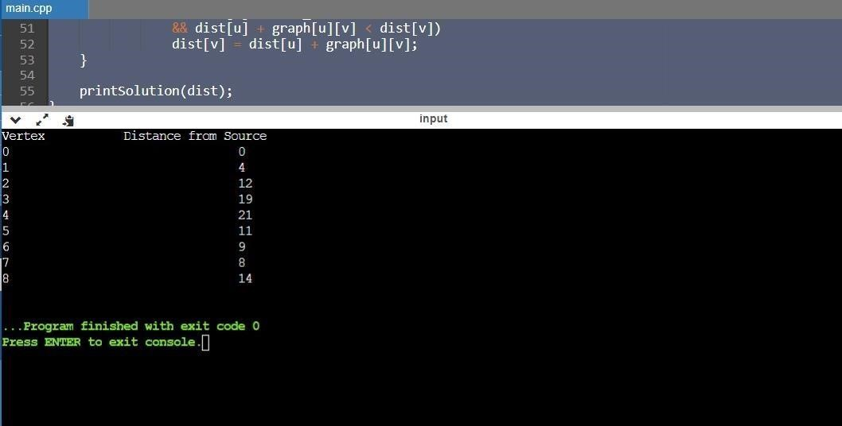

6. **Evaluation Grid (To be created as per the SOP and Assessment guidelines by the faculty):**

|  |  |  |  |
| --- | --- | --- | --- |
| Sr. No. | Parameters | Marks Obtained | Maximum Marks |
| 1. |  |  |  |
| 2. |  |  |  |
| 3. |  |  |  |